EVENTS
at
GROTTO

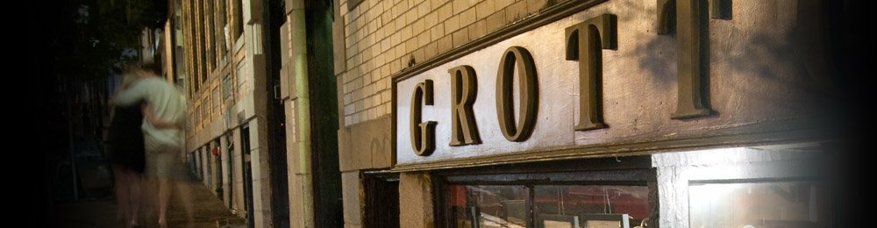
DECADENT CUISINE… SUBTERRANEAN SETTING…
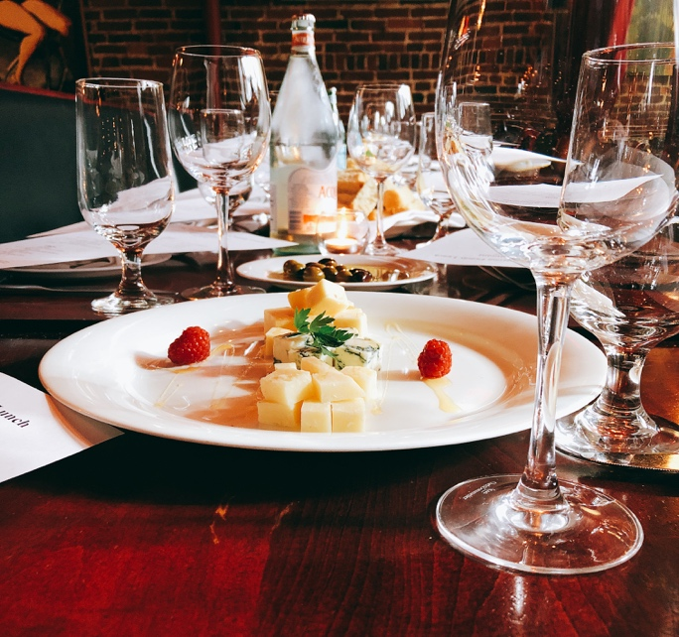
Occupying an inconspicuous, subterranean spot on the back side of Beacon Hill, Grotto has earned itself high praise with imaginative, contemporary Italian cuisine. The dining room's exposed brick walls covered with artwork from local creative-types give Grotto an intimate and cozy feel that's hard to find anywhere nearby.

Grotto Private Events

Grotto is available for private events for groups up to fifty guests. The entire restaurant can be yours for a whole afternoon or evening. Grotto charges no room fees, but instead establishes product minimums to have a private venue for your special occasion. Grotto utilizes its current menu to create Prix Fixe dinners for your event. Additionally, Grotto can always customize menus just for your event.

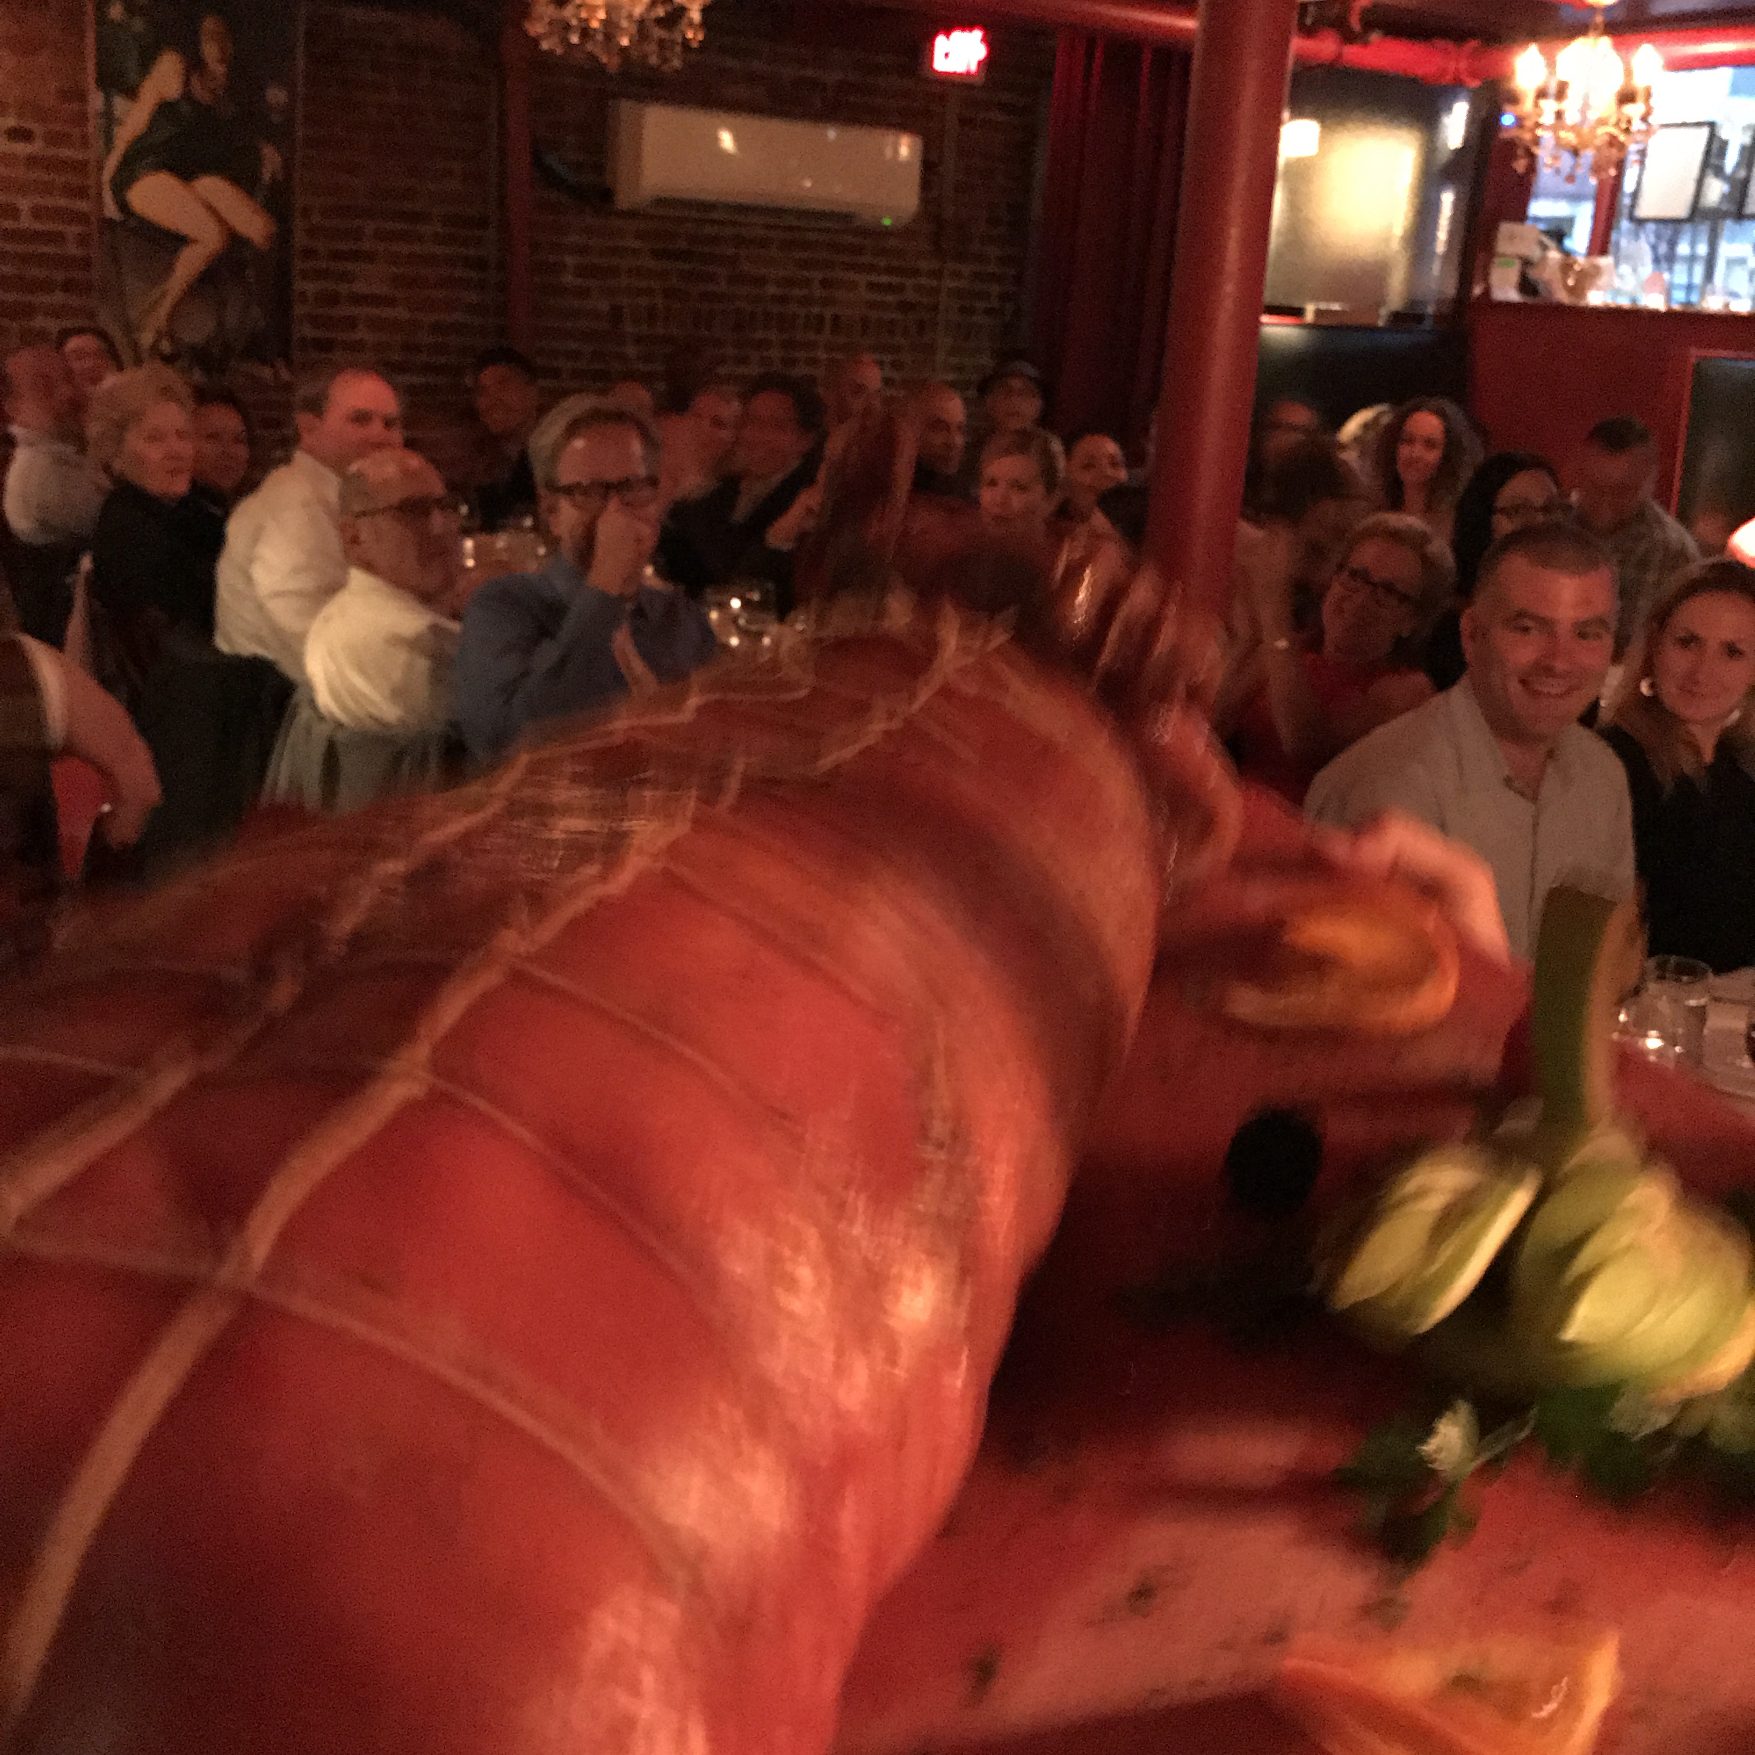
The ability of using Grotto’s entire restaurant gives your group the privacy that most restaurants can’t offer. Grotto makes for a perfect venue for speeches, gift exchanges, and toasts. Having the whole restaurant gives you and your guests a quaint and romantic setting for rehearsal weddings, anniversaries, and Birthday dinners. Grotto is also a good and convenient location for work related luncheons. Grotto can also be a great location for theme dinner parties like your own customized “Big Night” dinner.

DINNER MENU
Choose one Primi, Pasta/Secondi, and Dolce…

PRIMI

INSALATA || Baby arugula, Prosciutto di Parma, Reggiano parmesan, Lemon

SPINACI || Baby spinach, Beets, Spiced walnuts, Goat cheese, Raspberry vinaigrette

CAROZZA || Pan toasted buffalo mozzarella, Baby spinach, Black olives, Small tomatoes, Peppers, Caper berry

ZUPPA || Garlic soup, Black truffle, Parmesan, Bread crumbs

PICCATA || Mussels, Lemon, Capers, White wine

FONDUTA || Fontina cheese fondue, Beef tenderloin tips, Portobello mushrooms, Aged balsamic, Truffle oil

*MARE || Grilled calamari, White beans, Peppers, Arugula, Lemon vinaigrette

CAVATELLE || House prepared ricotta pasta, Sausage, Peas, Mushrooms, Pancetta, Cream

ZAFFERANO || Crab ravioli, Asparagus, Roasted tomatoes, Almonds, Saffron

GAMBA DELL' ANATRA || Crispy confit duck leg, Brussel Sprouts, Mustard aioli

PASTA

RISOTTO || Roasted tomatoes, Asparagus, Mushrooms, Parmesan

*FRA DIAVOLO || Butter poached lobster, Linguine, Spicy tomato sauce...$4 Supplement

GNUDI || Ricotta, Wild mushrooms, Spinach

BOLOGNESE || Tagliatelle, San Marzano tomatoes, Lamb, Pork, Beef

SPAGHETTI & MEATBALLS || Grotto’s insanely fabulous tomato sauce

GNOCCHI || Short ribs, Mushrooms, Gorgonzola

SECONDI

*CARNE || Grilled beef tenderloin, Reggiano risotto, Asparagus, Red wine sauce

PESCE || Pan roasted monkfish, Artichokes, Fingerling potatoes, Fennel, Cockles, White clam sauce

*PETTINI || Pan seared scallop "Ravioli", Wild mushrooms, Leeks, Arugula

*PETTO D' ANATRA || Espresso and Cocoa crusted duck breast, Lentils, Dried cherries, Madeira, Black truffle aioli

*CHICKEN PARMIGIANO || Ziti, Tomatoes, Mozzarella

VEAL ALTIMBOCCA || Veal cutlet, Prosciutto, Sage, Spinach, Creamy polenta, Marsala, Lemon

CONTORNI

ROASTED BRUSSELS SPROUTS || Bacon and parmesan

WILTED SPINACH || Garlic and olive oil

GRILLED ASPARAGUS || Reggiano and olive oil

ROASTED FINGERLING POTATOES || Herbs and garlic

DOLCE

CIOCCOLATO || Melting chocolate cake, Vanilla ice cream

BUDINO || Banana bread pudding, Caramel ice cream, Spiced walnuts

PANNA COTTA || Lemon, Raspberry sauce, Crispy pizzelle, Aged balsamic

ZABAGLIONE || Mixed berries, Madeira, Honey

TIRAMISU || Mascarpone, Ladyfingers, Espresso, Cocoa

LUNCH MENU

PRIMI

SPINACHI || Baby spinach, Beets, Goat cheese, Spiced walnuts, Raspberry vinaigrette

RUCOLA || Arugula, Prosciutto, Reggiano parmesan, Lemon vinaigrette

INSALATA MARE || Grilled calamari, White beans, Arugula, Peppers, Lemon vinaigrette

CAROZZA || Buffalo mozzarella “sandwich”, Spinach, Olives, Tomatoes, Peppers, Capers

ZUPPA || Garlic soup, Black truffle, Parmesan, Toasted bread crumbs

PICCATA || Mussels, Garlic, Lemon, Capers, White wine sauce

CAVATELLE || House prepared ricotta pasta, Sausage, Peas, Mushrooms, Pancetta, Cream

SECONDI

SPAGHETTI || Meatballs & Grotto's insanely fabulous tomato sauce

GNOCCHI || Short ribs, Mushrooms, Gorgonzola

RISOTTO || Mushroom, Roasted tomatoes, Asparagus, Parmesan

*CHICKEN PARMESAN || Ziti, Tomatoes, Mozzarella

BOLOGNESE || Tagliatelle, San Marzano tomatoes, Lamb, Pork, Beef

GNUDI || Ricotta dumplings, Wild mushrooms, Spinach

ZITI || Chicken, Asparagus, Parmesan, White wine sauce

*CRAB RAVIOLI || Asparagus, Roasted tomatoes, Almonds, Saffron

DOLCE

CIOCCOLATO || Melting chocolate cake & Vanilla ice cream

BUDINO || Banana bread pudding, Caramel ice cream, Spiced walnuts

PANNA COTTA || Lemon, Raspberry sauce, Crispy pizzelle, Aged balsamic

MIXED BERRIES || Zabaglione, Madeira, Simple syrup

“Big Night Dinner”
A massive feast modeled after the movie “Big Night,” in which two brothers attempt to revive an Italian restaurant with a dazzlingly ambitious meal. Guests are encouraged to dress in 1950s attire. “Slinky men in flashy suits, some with cufflinks and neon hankies, swirl wine.”

Primi Corso
Consommé || Chicken, Celery, Carrots, Onions, Homemade ziti.

Secondi Corso
Risotto || A combination of Vegetable, Short Rib, and Pesto Risottos.

Terzo “il Timpano” Corso
Il Timpano || ‘Timpano’ is Italian for gluttony. Kidding! Layers of pasta, cheese, choice of our Bolognese sauce or our Famous Insane sauce with any other ingredients that you may desire. These layers are then put together in a bowl covered with a large pasta sheet and inverted (when cooked) to form one big dome-like dish of all those delicious ingredients inside! In short, it’s the deadliest casserole ever!!

Quarto Corso
Entrée || Your choice of combinations of Duck Breast, Veal Saltimbocca, Beef Tenderloin, Salmon Piccata, Chicken Parmesan, Pan-seared Scallops, and a Roasted Pig served with your choice of Stuffed mushrooms, Mashed potatoes, Wilted Spinach, Brussels Sprouts, and Asparagus

Dolce Corso
Panna Cotta || Lemon, Raspberry sauce, Crispy pizzelle, Aged balsamic

Grotto Wine List

Sparkling Wine
NV | Ferrari, Trentino-Alto Adige, Metodo Classico Brut | 75
2015 | Bellenda, Prosecco di Valdobbiadene, San Fermo Brut | 55
2015 | Villa Sandi, Prosecco Valdobbiadene di Cartizze, Brut | 120
 | White Wine
2014 | Pojer e Sandri, Tentino-Alto Adige, Nosiola Dolomiti | 65
2015 | Istituto Agrario San Michele, Trentino, Riesling | 55
2014 | Puiatti, Friuli-Venezia Giulia, Gewürztraminer CUR | 68
2016 | Pighin, Friuli-Venezia Giulia, Sauvignon Blanc | 48
2016 | Masi Agricola, Veneto, Masianco Pinot Grigio e Verduzzo | 55
2015 | Bruno Giacosa, Piedmont, Arneis Roero | 75
2016 | Michele Chiarlo, Piedmont, Gavi | 62
2015 | Monastero Suore Cistercensi, Lazio, Trebbiano Coenobium | 65
2016 | La Spinetta, Tuscany, Vermentino | 45
2016 | Castello della Sala, Umbria, Chardonnay Bramito | 68
2015 | Fratelli Urciuolo, Campania, Greco di Tufo | 60
2015 | Villa Matilde, Campania, Falanghina | 50
2011 | Donnafugata, Sicily, Chardonnay Chiaranda | 120
 | Red Wine
2014 | Manincor, Trentino-Alto Adige, Reserve Del Conte | 62
2013 | Maso Poli, Trentino, Pinot Noir Superiore | 84
2014 | Sandrone, Piedmont, Barbera D’Alba | 95
2015 | Sottimano, Piedmont, Barbera D’Alba Pairolero | 80
2015 | Vietti, Piedmont, Dolcetto D’ Alba Tre Vigne | 62
2016 | E. Pira e Figli, Piedmont, Dolcetto D’Alba Chiara Boschis | 68
2015 | Giacomo Ascheri, Piedmont, Pelaverga di Verduno | 52
2013 | Silvio Giamello, Piedmont, Barbaresco Vicenziana | 108
2013 | Prunotto, Piedmont, Barbaresco | 130
2012 | Agricola Brandini, Piedmont, Barolo | 125
2013 | Casa E. Di Mirafiore, Piedmont, Barolo | 105
2015 | Speri, Veneto, Valpolicella La Roverina | 67
2014 | Tommasi, Veneto, Valpolicella Superiore Classico Ripasso | 75
2007 | Le Ragose, Veneto, Amarone della Valpolicella Classico | 165
2014 | Tuffo, Veneto, Amarone della Valpolicella Classico | 120
2015 | Campo Al Mare, Tuscany, Bolgheri Rosso | 88
2013 | Castello di Fonterutoli, Tuscany, Cabernet Sauvignon Philip | 125
2013 | Cabreo, Tuscany, Il Borgo | 148
2016 | Tenuta San Guido, Tuscany, Le Difese | 98
2014 | Castello di Querceto, Tuscany, Toscana Rosso | 45
2013 | Tenuta di Cappezzana, Tuscany, Carmignano | 88
2015 | Tenuta dell’ Ornellaia, Tuscany, Bolgheri Le Volte | 102
2014 | Castello di Ama, Tuscany, Chianti Classico Gran Selezione | 145
2014 | Tenuta di Nozzole, Tuscany, Chianti Classico Riserva | 60
2015 | Castello dei Rampolla, Tuscany, Chianti Classico | 105
2014 | Isole e Olena, Tuscany, Chianti Classico | 75
2015 | Polazzo, Tuscany, Rosso di Montalcino | 82
2012 | Caparzo, Tuscany, Brunello di Montalcino | 115
2012 | Fattoria dei Barbi, Tuscany, Brunello di Montalcino | 170
2012 | Tenuta la Fuga, Tuscany, Brunello di Montalcino | 160
2015 | Velenosi, Marche, Lacrima di Morro d’ Alba | 50
2015 | Zaccagnini, Abruzzo, Montepulciano d’ Abruzzo | 56
2010 | Castelbuono, Umbria, Montefalco Sagrantino Carapace | 108
2012 | Arnaldo Caprai, Umbria, Montefalco Sagrantino | 68
2011 | Terredora di Paolo, Campania, Taurasi | 90
2012 | Re Manfredi, Basilicata, Aglianico del Vulture | 102
2015 | Mandrarossa, Sicily, Cabernet Sauvignon | 52
2014 | COS, Sicily, Cerasuolo di Vittoria Classico | 108
2016 | Tenuta delle Terre Nere, Sicily, Etna Rosso | 60

NOTES:

________________________________________________________________________________________________________________________________________________________________________________________________________________________________________________________________________________________________________________________________________________________________________________________________________________________________________________________________________________________________________________________________________________________________________________________________________________________________________________________________________________________________________________________________________________

Grotto Events

Room and Guarantee:
A 10% deposit is required to hold the space. The deposit is based on either a minimum charge or other mutually agreed amount predetermined by Grotto and you (the “client”). The deposit is applied towards the final bill and the credit card will be held on file, but it is not required that this card be used to make the final purchase.

Payment:
The Grotto accepts all major credit cards (except Discover), or cash as a form of payment. Checks are not accepted. The bill must be paid in full by the client immediately following the event.

Cancellation Policy:
After the credit card information has been received, the event is considered finalized. The function must be canceled at least 7 days in advance or there will be a late cancellation fee of $500 charged to the card on file. A final guest count is due 48 hours in advance, and that count will be the basis for what is charged on the night of the event if the number of attendees is less than the 48 hour count. In the case that an event is canceled less than 48 hours in advance, the entire minimum charge agreed upon will be charged. The total deposit amount will be refunded to you, in the case of cancellation of the event on behalf of the Grotto restaurant or there is an “act of god” which forces Grotto or your party to cancel the reservation.

Smoking:
Smoking is prohibited inside the Grotto in accordance to Massachusetts state law.

Food and Alcohol:
All alcohol is to be provided by the Grotto in accordance to Massachusetts state law. All food is to be provided by the Grotto. If it is prearranged, there will be a plating fee for dessert or other items brought in from an outside source.

Tax and Gratuity:
There will be an automatic gratuity of 18% added on to the final bill. There will also be 7% Massachusetts state tax added. If your group is tax exempt the proper paperwork is required.

Parking:
There is meter parking across the street until 8PM and there are also several parking garages in the area.

Public Transportation:
Take the Red Line to Park Street. Walk up Park Street. Take a left onto Bowdoin street. The Grotto is located halfway down the hill on your left hand side at 37 Bowdoin Street.

Contact Information:
Phone:617.227.3434
Fax: 617.422.0041
E-mail: grottorestaurant@aol.com

